Stations for the Para Empezar Unit –Directions – Due Friday, February 2, 2018
There are four stations to complete.
1. Why Study Spanish? Worksheet and video – Students must hand in a complete worksheet individually, but may work together to complete it.
Students are to complete questions to a comprehension sheet in English about factual information on the impact of learning Spanish in employment and school and the history of Spain and the Spanish language.
- My website >Spanish 1, Click on Spanish 1 >Class Documents, click on Class Documents > Click on Para Empezar Button go to the video
The assignment includes the first approximately five minutes of the first video for the Para Empezar Chapter.
2. Screen shots of practice from the Publisher’s website – Students should go to the publisher’s website and complete their choice of two practice activities or test preparation review.
- My website >Spanish 1> Class Documents > Publisher’s website > Para Empezar ( It’s at the top), Click on Practice activities to complete any of the five activities los números, el cuerpo, la sala de clases, el calendario, el tiempo or theTest Preparation. You must screen shot the results after you have competed each activity. Paste the screen shots onto a document such as a word document and hand it in on my website with your full name, date, period, and title)
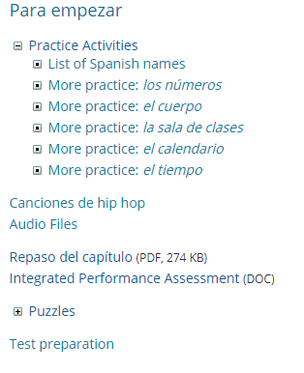
3. Speaking on the phone in Spanish – Students will call my google voice number to leave a message in Spanish. Students must introduce themselves, stating their name and additional information. You can include answers to the questions below to help guide what you might say.
- My website > contact , Use the google voice phone number. You will have to leave a message in Spanish after the beep.

¿Cómo te llamas?
¿Cuántos años tienes?
¿Cómo se escribe el nombre?
¿Cuándo es tu cumpleaños?
¿Cómo estás?
¿Qué tiempo hace?
¿Qué hora es?
¿Cuál es la fecha?

4. Spoken Dialog – Students will have a short conversation with me in Spanish. Students should be prepared to ask me at least two questions and to answer at least two questions I will ask. Use the list for number 3 above, as a guide. This portion will be the oral portion of the test.

