Day of the Deaad and 3B Stations
Name ____________________________________ Date _______________ Class ___________
PART A: Look at the website for this store below the questions on this file.
- What do they sell?
- What do you think the word disfraces means?
Word in Spanish | Your guess in English | Actual English word
infantil
hombre
mujer
maquillaje
máscaras
postizos
pelucas
sombreros
decoración
buscar

Look at the first set of costumes and labels.
What is the word for witch? a) adulto b) disfraz c) bruja
What does calabasa mean? a) mummy b) pumpkin c) baby
Which costume is of a borrowed English name ? What does it mean? ___________________________________________

Look at the second and third rows of costumes on this file.
Spanish word | My Guess in English | Actual English word
esqueleto
murciélago
fantasma
infantil
mago
momia
monstruo

Look at the last row of costumes to complete the chart.
English word | Spanish word used
cape
scarecrow
clown

PART B - Infographic – Flowers – Day of the Dead - Infographic
Scroll down to the bottom of this file. Answer the questions according to the infographic.
- ¿De qué color es la flor? __________________________________ (answer in Spanish)
- For what is 92% of the production of this flower used? ________________________________________
- This infographic shows a map of the country of ____________________________________.
- In which parts (states or estados) of Mexico is this flower grown? ____________________________________________________________________________________________________________________________________________________________
- 70% is grown in the state of ____________________________________________________________.
- In what month is it harvested ( se cosecha) ? ________________________
PART C – Comparisons between Day of the Dead and Halloween - infographics
Go to this site. List at least five differences or similarities between Halloween and Day of the Dead.
Look at this site and go to the infographic at number 3.
- List 5 more countries where Day of the Dead is celebrated.
- Name 5 things placed on the altar. Write the words in Spanish and English.

Part A - Store Website Page
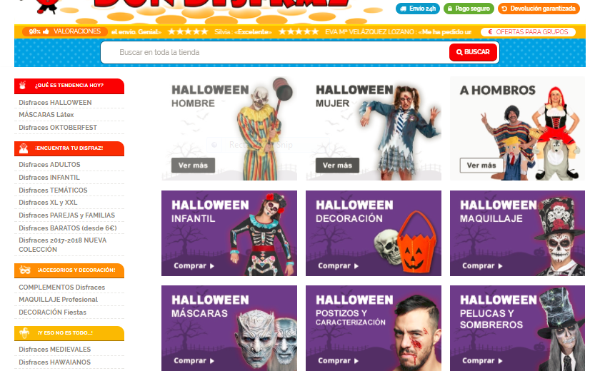

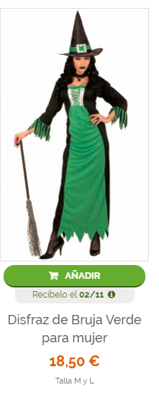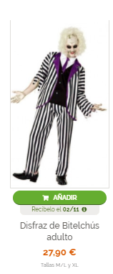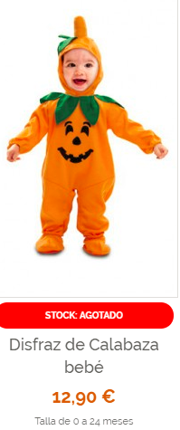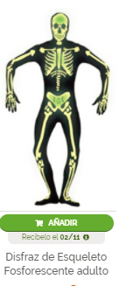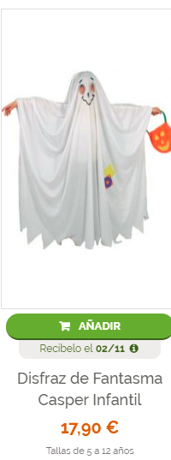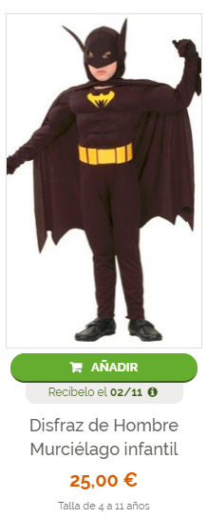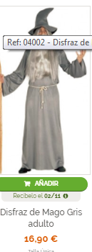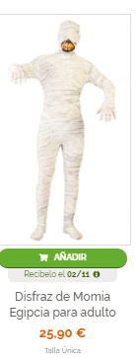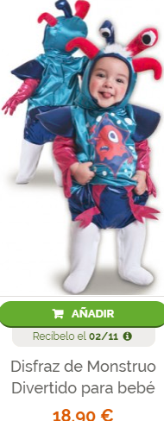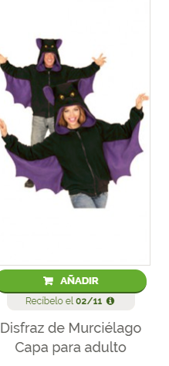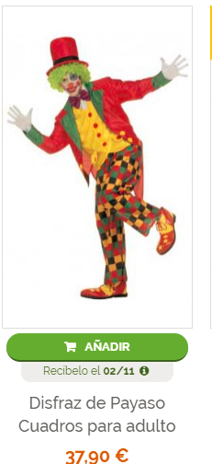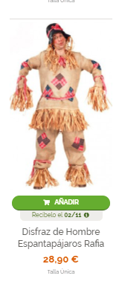

Part B - Flowers
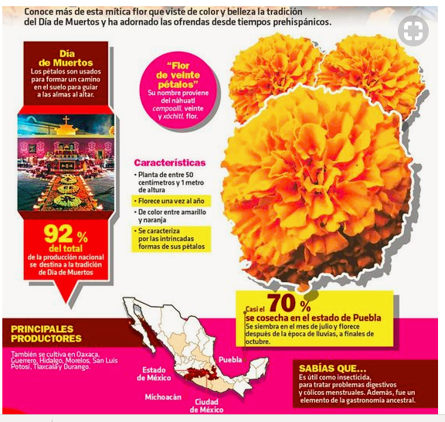

PART D – SKULL
Color a skull. Write your first and last name on the back. Show it to me for credit.
PART E - Go to Edpuzzle to view videos due Nov. 9.

