Spanish 1 - La Diabetis
Prereading - Ask a three people how many people he or she knows with diabetes. Write the answer here in Spanish.
¿Cuántas personas conoces con diabetes?
Conozco _________________ personas con diabetis.

Interpretive reading
1. Diabetic symptoms
Look at this infographic.
Diabetis Mellitus . What are some symptoms of diabetes? Write the Spanish and the English words.

2. Alimentos para los con diabetis\Foods for those with diabetes
What foods are best for those with diabetes? Write the words in English and Spanish.
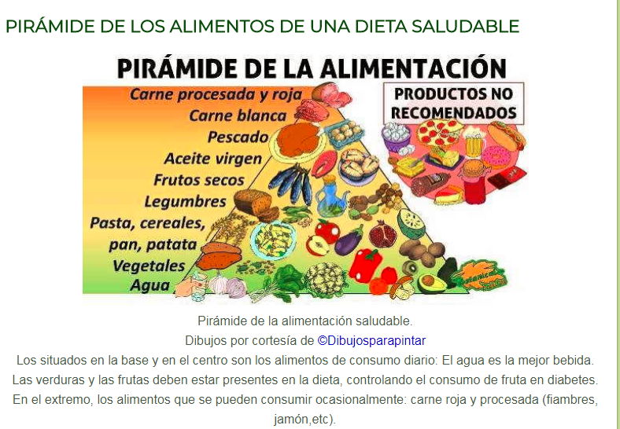

3. Statistics about diabetes.
Write three interesting statistics about diabetes. ( look at the bottom of the article and look for numbers - NOTE: cifras= statistics, data, numbers, fallecer = to die)

Lo que debes saber sobre la Diabetes

