Eventos Actuales Current Events

Sra. Oke-Bello
Spring 2017
Dates for presentations:

Third quarter
#1 Thursday, February 9, 2017
#2 Friday, March 3, 2017

Fourth quarter
#3 Friday, April 7, 2017
#4 Friday, April 28, 2017

Part of the learning a new language is becoming more globally aware. We will be learning about current events from Spanish-speaking countries and analyzing how they impact the Spanish-speaking communities and our community. You will be assigned a region on which to report for each current event. The last current event will be of your choice.
Every interim period you will research current events from your assigned region. You will need to prepare two articles each quarter.
- You will hand in a printed hard copy of the article or attach the link to the article from the website of a respected news source to my Echo or Weebly . Make sure the date is included on the article and that it is no more than 1 month old. You will write a summary and reflection of the article using the attached writing guidelines.
  - The article must be current – no more than one month old.
  - Identify the content connection by listing it on the written portion. See topics below.
  - You will be required to share your article, in English, with classmates every interim period. You will be required to listen to the articles of peers and write reflections If you do not have the article or presentation on that date, you will receive a significantly reduced score as this is a standing assignment.
  - Your presentation should be approximately one to two minutes in length.
  - Part the presentation includes identifying the geographical location of the article on the world map.
  - You must know the information in your article. You will be able to use a note card for the presentation, not a phone.
It is your responsibility to remember that the current events are due.
Content Connection topics – there may be overlap.
Politics science technology arts health sports
Business education home cuisine weather

Writing guidelines - Hand in in writing on the website:
- Identify the content connection.
- Summary: (Who? What? When? Where? How? Why?) Approximately five to seven sentences.
- Reaction: Respond to each of the following.
1. How does this impact the Spanish-speaking community?
2. How does this impact your community?
3. Describe another event of which it remind you.
4. State remaining questions you have.
5. Write and interesting quote or surprising fact from the article
and why it is interesting or surprising.

 | EMERGING | DEVELOPING | PROFICIENT | ADVANCED
AGENCY (2)  Article handed in | -Article does not meet all requirements | -Article meets requirements | -Article meets requirements | -Article meets requirements
CONTENT (3)  Map skills | -Student has difficulty identifying on map. | -Student can identify the continent or approximate location on map. | -Student accurately identifies location on map. | -Student accurately identifies location on map and uses cardinal directions in Spanish.
CONTENT(20) &  WRITTEN EXPRRESSION(2)  Summary | -Student has significant parts missing showing limited understanding.  -Significant errors in grammar and mechanics. | -Student is missing some parts, but shows overall understanding.  -Some errors in grammar and mechanics | -Student summarizes accurately and highlights the 5ws.  -Writing mechanics and grammar are grammatically correct. | -Student summarizes all parts of the summary and clearly articulates the impact of the event beyond communities stated in the article.  Writing mechanics and grammar are correct.
ORAL COMMUNICATION (3) | -Limited success with appropriate body positioning, eye contact, pacing, volume and intonation that significantly impacts comprehensibility  -Active listening. | -Some difficulty with appropriate body positioning, eye contact, pacing, volume and intonation impacting comprehensibility  -Active listening. | -Mostly appropriate body positioning, eye contact, pacing, volume and intonation.  -Active listening. | -Appropriate body positioning, eye contact, pacing, volume and intonation.  -Active listening.

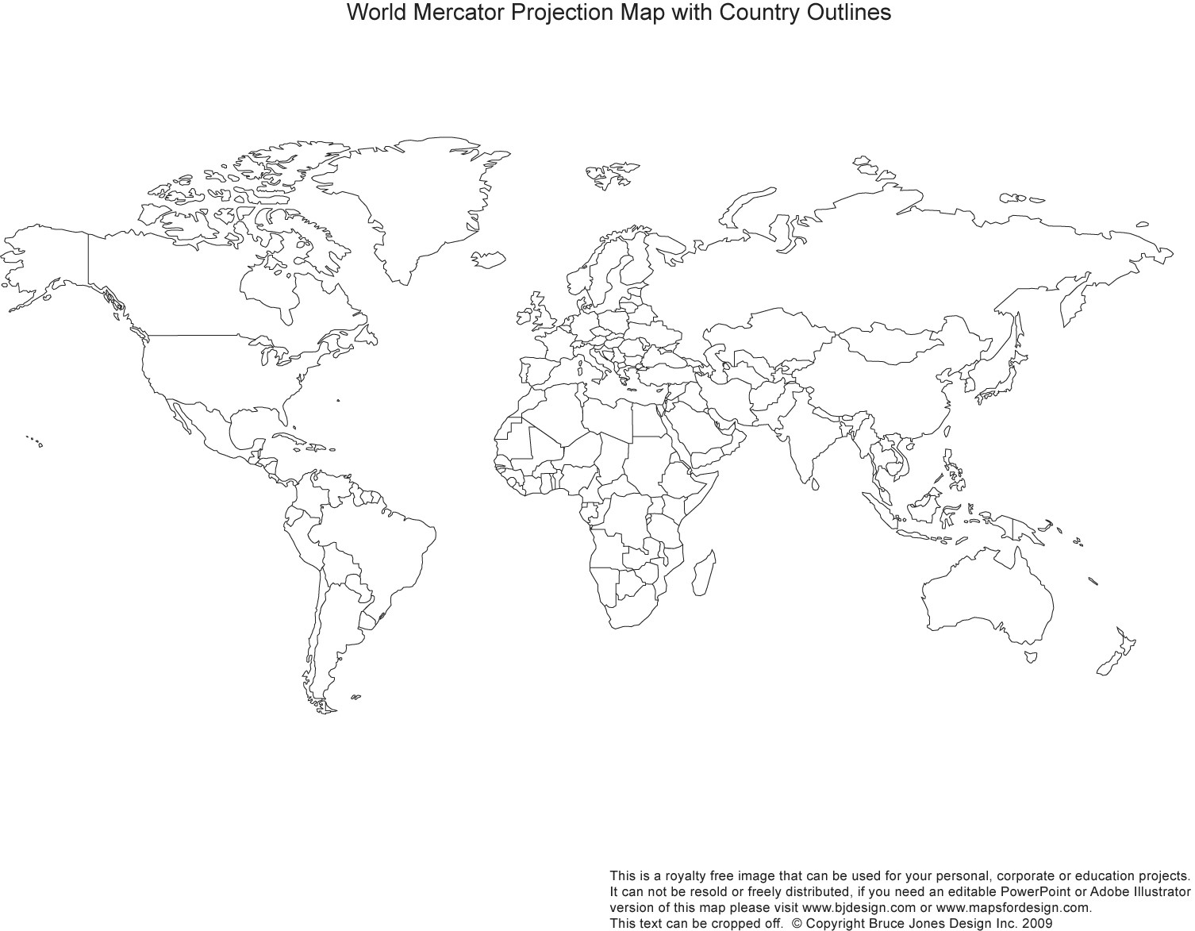

Eventos Actuales Current Events

Sra. Oke-Bello
Native Speakers
Fall 2016
Dates for presentations:

First quarter
#1 Friday, August 26
#2 Friday, September 16

Second quarter
#3 Thursday, October 20
#4 Thursday, November 10

Part of the learning a new language is becoming more globally aware. We will be learning about current events from Spanish-speaking countries and analyzing how they impact the Spanish-speaking communities and our community. You will sign up for two Spanish-speaking countries to keep abreast of this semester. I will assign you the third country.
Every interim period you will research current events from your three assigned countries. You will need to prepare two articles each quarter.
- You will hand in a printed hard copy of the article or attach the link to the article from the website of a respected news source in Echo. Make sure the date is included on the article. You will include the web address of the website visited or cite your source.
- You will write a summary and reflection of the article using the attached writing guidelines.
  - The article must be current – no more than one month old.
  - Identify the content connection by listing it on the written portion. See topics below.
  - You will be required to share your article, in English, with classmates every interim period. As a student in Native Speaker Spanish you will be required to write in Spanish. You will be required to listen to the articles of peers and write reflections. Each interim period, several students will be asked to present for the class orally. If you do not have the article or presentation on that date, you will receive a significantly reduced score as this is a standing assignment.
  - Your presentation should be approximately one to two minutes in length.
  - Part the presentation includes identifying the geographical location of the article on the world map.
  - You must know the information in your article. You will be able to use a note card for the presentation, both to the peer and to the class.
It is your responsibility to remember that the current events are due.
Content Connection topics
Politics science technology arts health sports
Business education home cuisine weather

Writing guidelines - Hand in in writing on the website:
- Identify the content connection.
- Summary: (Who? What? When? Where? How? Why?) Approximately five to seven sentences.
- Reaction: Respond to each of the following.
1. How does this impact the Spanish-speaking community?
2. How does this impact your community?
3. Describe another event of which it remind you.
4. State remaining questions you have.
5. Write and interesting quote or surprising fact from the article
and why it is interesting or surprising.

 | EMERGING | DEVELOPING | PROFICIENT | ADVANCED
AGENCY (2)  Article handed in | -Article does not meet all requirements | -Article meets requirements | -Article meets requirements | -Article meets requirements
CONTENT (3)  Map skills | -Student has difficulty identifying on map. | -Student can identify the continent or approximate location on map. | -Student accurately identifies location on map. | -Student accurately identifies location on map and uses cardinal directions in Spanish.
CONTENT(20) &  WRITTEN EXPRRESSION(2)  Summary | -Student has significant parts missing showing limited understanding.  -Significant errors in grammar and mechanics. | -Student is missing some parts, but shows overall understanding.  -Some errors in grammar and mechanics | -Student summarizes accurately and highlights the 5ws.  -Writing mechanics and grammar are grammatically correct. | -Student summarizes all parts of the summary and clearly articulates the impact of the event beyond communities stated in the article.  Writing mechanics and grammar are correct.
ORAL COMMUNICATION (3) | -Limited success with appropriate body positioning, eye contact, pacing, volume and intonation that significantly impacts comprehensibility  -Active listening. | -Some difficulty with appropriate body positioning, eye contact, pacing, volume and intonation impacting comprehensibility  -Active listening. | -Mostly appropriate body positioning, eye contact, pacing, volume and intonation.  -Active listening. | -Appropriate body positioning, eye contact, pacing, volume and intonation.  -Active listening.

