Clothing assignment – interpretation – reading and listening - Spanish 2 chapter 2B

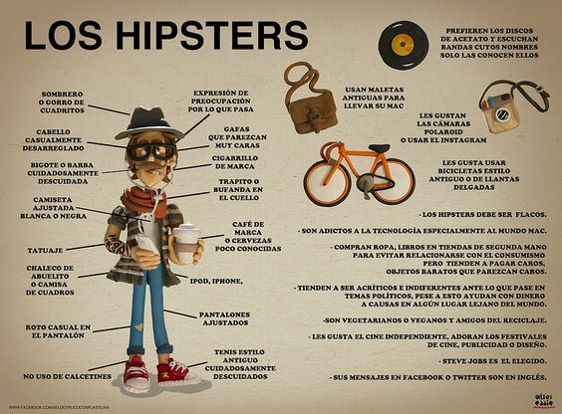
When looking at the infographic labeled Los Hipsters.
Identify the meaning of these words:
Tatuaje _________________________________ roto ___________________________________

Calcetines ______________________________ desarreglado _________________________________
What addiction do hipsters have according to the infographic? __________________________________
List three things hispters like according to the infographic?
1. ___________________________________
2. ___________________________________
3. ___________________________________

Watch the video about Mayan clothing from Guatemala. Answer these questions.
The woman speaking, Ms. Calel, states that traje típico ( traditional clothing) is important because it is the I ____________________ of Indigenous people.
Define indigenous. _______________________________________________________________________________________________________________________________________________________________________________________________________________________________________________________________
According to the speaker, her ancestors taught that the earth and the sky each have a
h _______________________ and that everything deserves r_______________________________.
The colors of the cloth remind people that we must care for the _____________________________.
What is unique about what the clothing tells people? ___________________________________
______________________________________________________________________________
The hair wrap is for the grooming for the preparation of ___________________________
The belt represents the _____________________________ of a woman.
In the second video a woman speaks about the article of clothing called a h_______________________.
What are some symbols and their meanings she describes?

